

**CSM3313**

**IOT COMPUTING**

**SEMESTER 2 SESSION 2022/2023**

**LAB 2 REPORT**

**PREPARED BY:**

|  |  |
| --- | --- |
| **ARUN MUGILAN A/L SARGUNAN** | **S63746** |

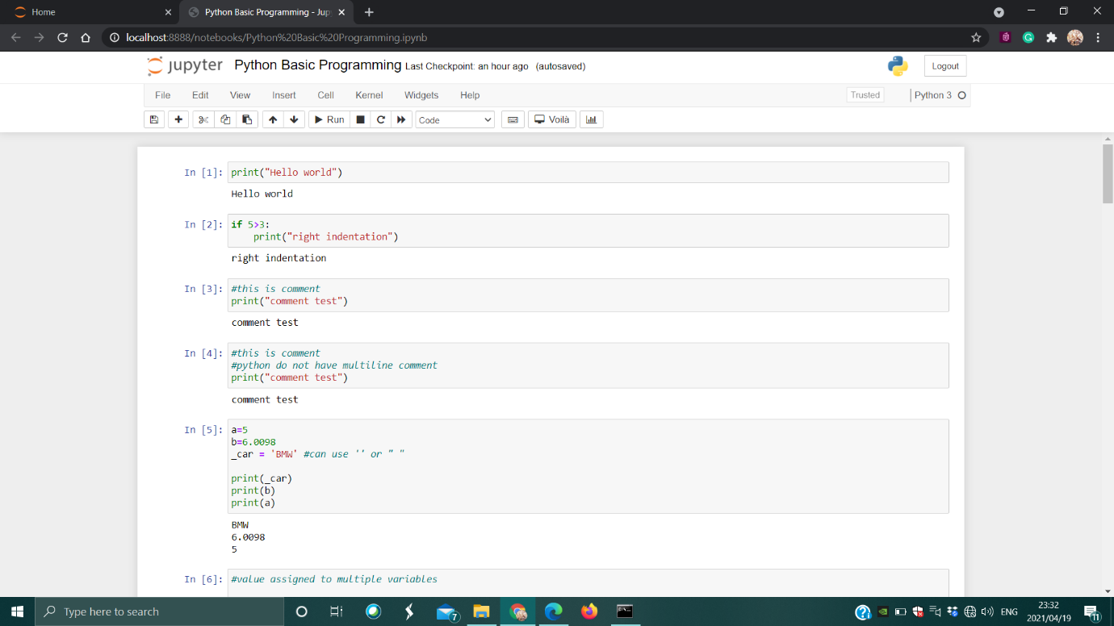

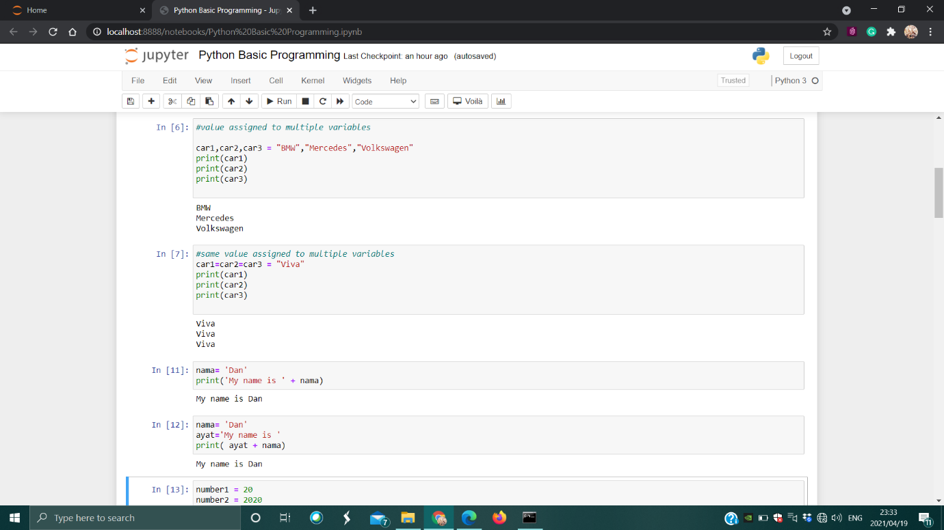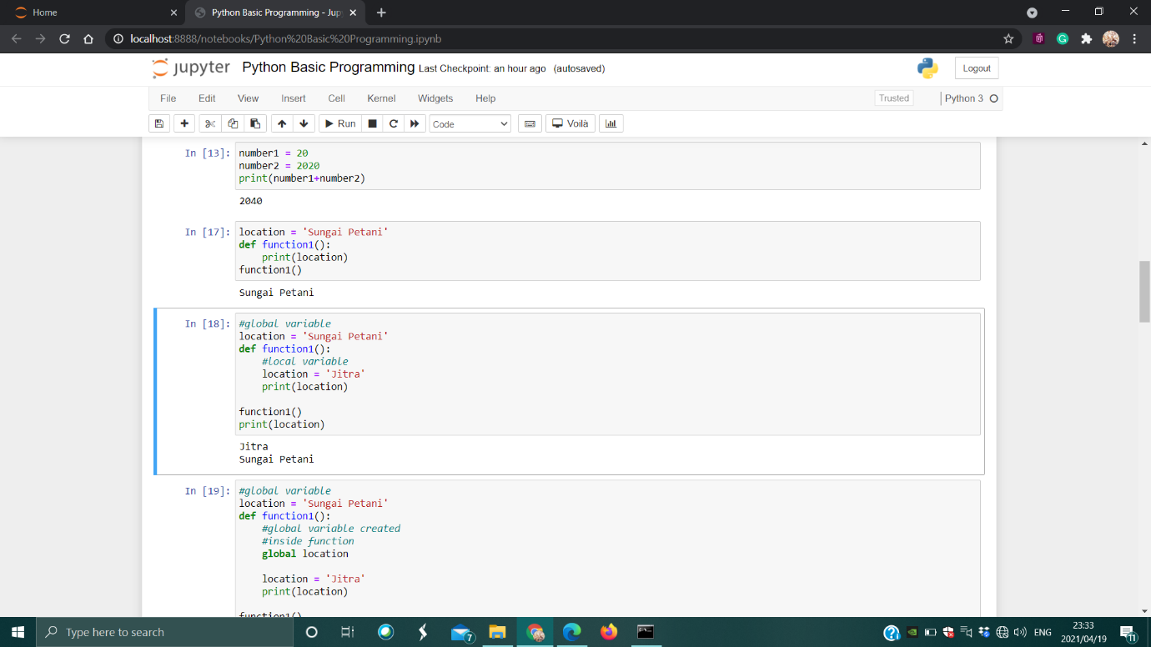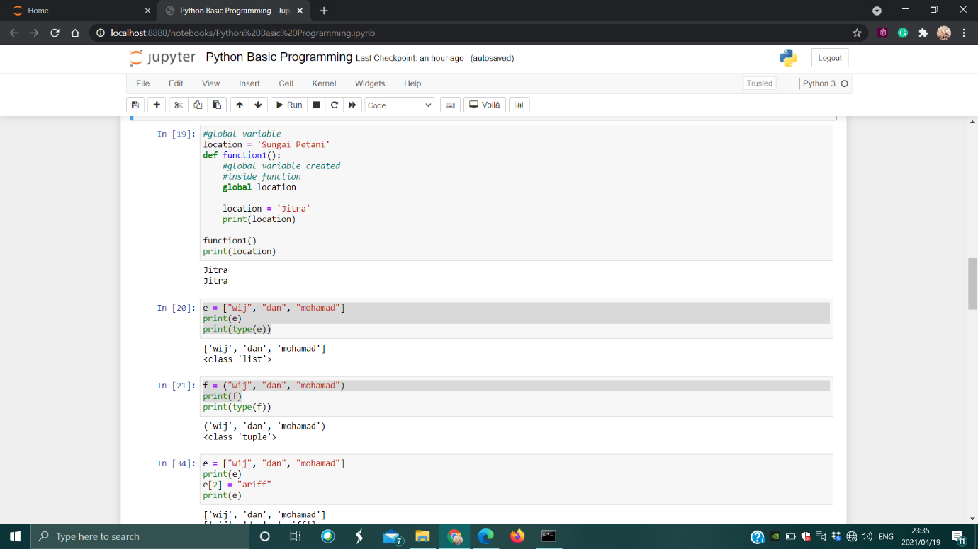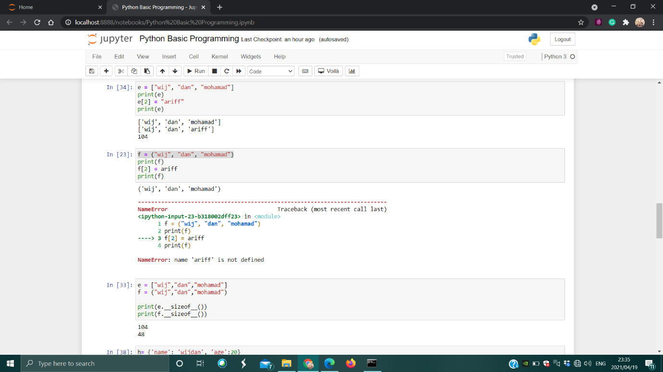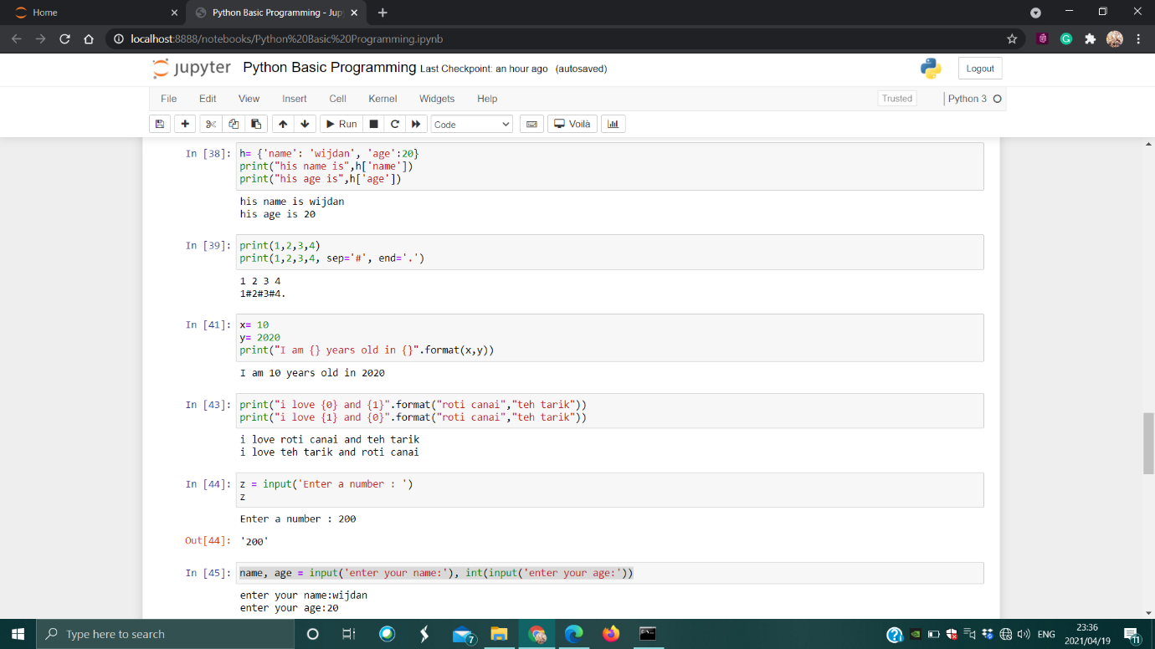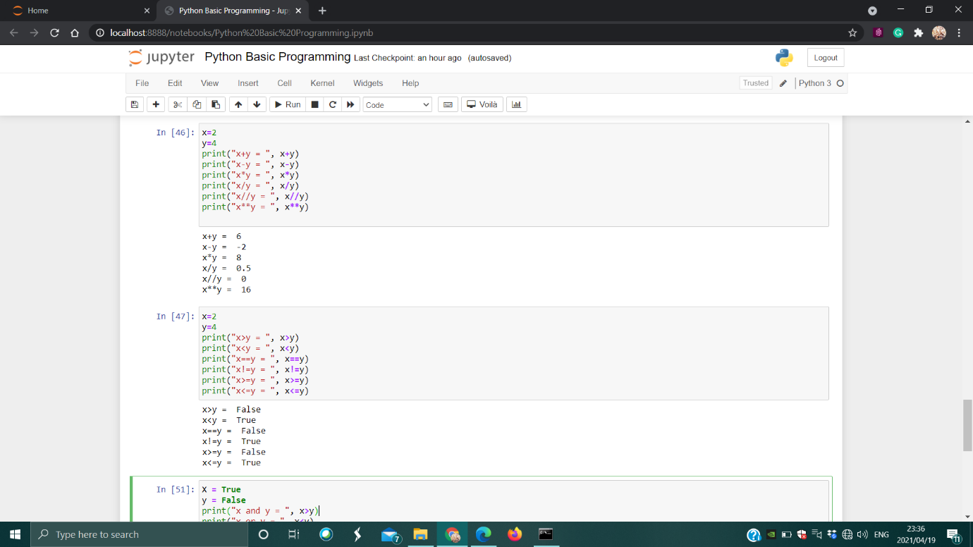

Exercise:

